**CPSC 4420/6420: ARTIFICIAL INTELLIGENCE**

Q2- POSTED SEP 4 DEADLINE SEP 7, 4:59 PM NAME: Reeves Farrell

**Q1**- Consider the following 8-piece puzzle. Find the number of states. 2 point

The number of states is 9! or 362880.

**Q2**- Consider the problem of flipping pancakes using a spatula. In particular, you are given a stack of four pancakes that have different sizes. A spatula can be inserted at any point in the stack and used to flip all pancakes above it. The goal is to stack the pancakes in order of size such that the biggest one sits at the bottom, the second biggest one lies on top of that, and so on (see figure). To formulate the problem as a search problem, please propose: [4 points]

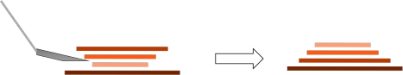

1. A state space

I am going to use the state space above, where the second biggest pancake is on top, the third largest pancake is below that, the smallest pancake is below that, and then the largest pancake is on bottom.

1. An action space

In this scenario, an action space is inserting the spatula at any point in the stack. You can either do the top pancake, the top two, the top three, or the whole stack; this leads to four different action spaces. In this case, we would use the action space that flips the top three pancakes.

1. A transition model [provide an example for a transition from one state to another by taking an action]. Is the transition model probabilistic or deterministic?

In this scenario the transition model is shown above. We start with the top three pancakes being largest on top and smallest on bottom. Once we flip the top three, we end up with the whole stack going from smallest on top to largest on bottom. The cost is not specified so we assume it to be 1 for every action. This model would be deterministic as there is no random aspect involved.

1. A goal test to determine that the problem has been solved.

According to the image above, the goal state is the stack of pancakes to the right of the arrow. This stack has the pancakes going from smallest on top to largest on bottom. If the pancakes are in that order then the problem as been solved.

**Q3**- Consider the checkers game. You can find the instructions in the following links: <https://www.wikihow.com/Play-Checkers> <https://www.youtube.com/watch?v=ScKIdStgAfU&t=48s>

[4 points]

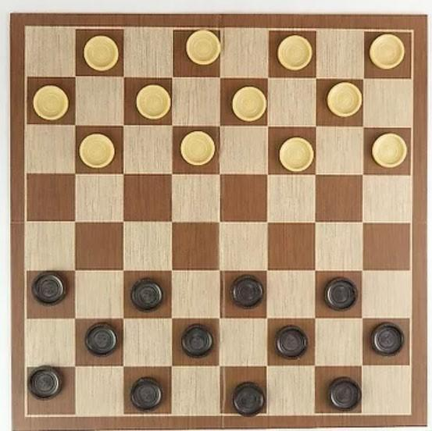

* 1. For this game find the number of states if all pieces are in. In other words, in how many ways we can place 12 equal white and 12 equal black pieces on the black cells of an 8x8 chessboard?

There are 225,792,840 states.

* 1. Repeat part a if the pieces are not equal and labeled from 1 to 24.

There are 12! * 12! states. Woweezowee that’s a big number.

* 1. Now, again consider that all black pieces are equal and so are the white ones. Find the total number of states, noting that when playing the games, some of the pieces may get killed and go off the board. In other words, we can m white and n black pieces on board where 1 ≤ 𝑚𝑚 ≤ 12 and 1 ≤ 𝑛𝑛 ≤ 12 is a number between 1 and

12. For example, m=3 and n=12 means that we have 3 white and 12 black pieces. Also, note that for any combination of m and n, there are many ways, we can place them on the board. Considering the above facts, calculate the total number of states.

There are 977232279139692 total states for this scenario.

* 1. Consider the state shown in the figure below, and let’s assume that it is black’s turn to move. How many actions are possible in this state? Represent the state transition for one of the actions. (Who would be the next state for a given action).

There are 8 possible actions for this state for the black turn. If the top black piece in the first column of the board moved diagonal one space, it would allow the black piece in column two to move. This state would block the piece in column three from moving.

